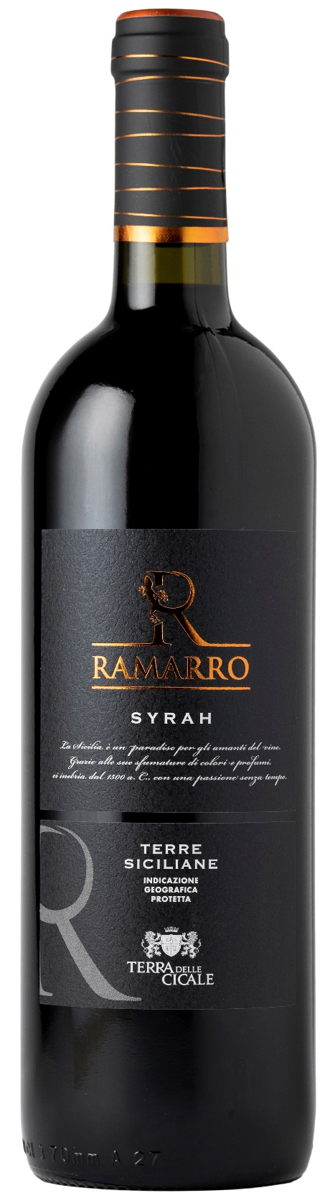
SYRAH TERRE SICILIANE IGP – RAMARRO

Grape: Syrah 100%
Alc. Vol.%: 13
Vintage: 2024
Residual sugar g/l: 6,5
Total acidity g/l: 5,2
Region: Sicily
Production zone: Vineyards in the area of Mazara del Vallo (Trapani)
Capacity: 750ml

CHARACTERISTICS

Vinification: Traditional peel maceration at a controlled temperature of 26-28°C for 7 days
Aging: At least 6 months in steel tanks
Yield per ha: 14000kg
Colour: Intensive and brilliant red
Bouquet: Pleasant notes of berries and violets
Flavour: Full-bodied, round and semi-dry

SERVING SUGGESTIONS

Best enjoyed with stewed meat, venison and light cheese.
Serving temperature 18 °C
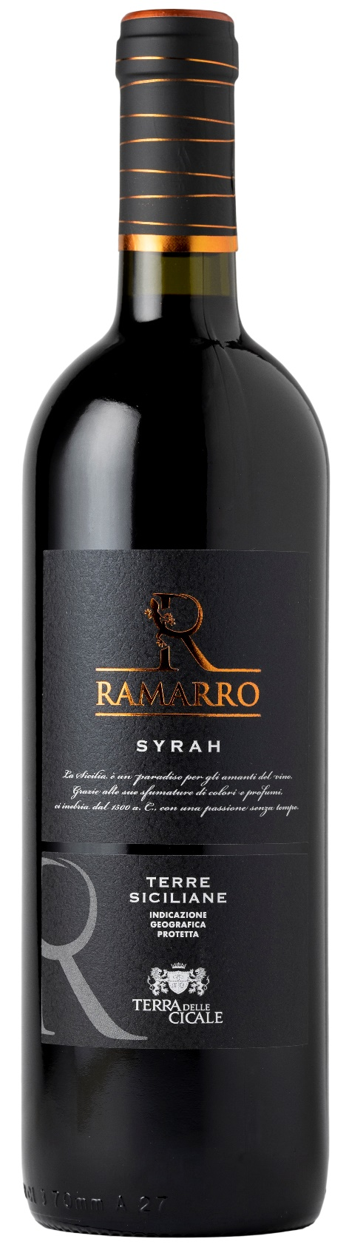
TECHNICAL INFORMATION / PALLETIZING

Size 750ml:
Article Nr. V11003A
GTIN-13 bottle 8017868002512
GTIN-13 carton 8017868002550
Closure Cork/Screwcap
Bottles / carton 6 bottles
Pallet size 80x120cm
Cartons/layer 25
Cartons/pallet 125
Kg/carton 7,0
Kg/pallet 892

Contains sulphites
GMO Free
Revisione 01. 14.05.2026

